**Test Report**

**Tester: Mirjana Velagic**

**Date of Execution: 13th July 2023**

**Web page: http://demo.baasic.com/angular/starterkit-photo-gallery/main**

**Test Plan Summary:**

The test plan focused on two types of testing: Functional Testing and Usability Testing. The tool used for testing was Selenium.

**Test Results:**

Test Case 19: Photo Upload

Result: Fail

Observation: The photo upload functionality within an album resulted in a 404 Not Found error when trying to view the uploaded photo within the album.

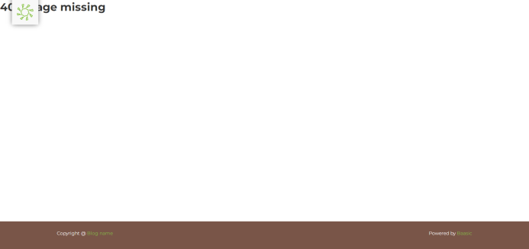

Test Case 20: Photo Deletion

Result: Pass (with occasional irregularities)

Observation: Photo deletion was successful, but occasional irregularities were observed during the execution.

Test Case 21: Album Deletion

Result: Pass (with occasional irregularities)

Observation: Album deletion was successful, but occasional irregularities were observed during the execution.

Test Case 22: Album and Photo Display Verification

Result: Pass (with occasional irregularities)

Observation: The display of albums and photos had occasional irregularities, but overall the functionality was as expected.

**Recommendations for Future Updates:**

Number of Images as Search Results: Include information about the number of images returned in search results.

Bulk Photo Management: Implement functionality for users to perform bulk operations such as uploading or deleting multiple images or entire folders instead of individual images.

Rename Photo/Album: Add an option to rename photos and albums, as this functionality would be useful for users.

Password Lockout Mechanism: Implement a mechanism to alert users about their account being locked after a certain number of unsuccessful login attempts. Provide clear instructions for unlocking the account after the lockout period.

Password Visibility Toggle: Include a password visibility toggle to allow users to verify the accuracy of their entered password.

Account Unlocking Notification: Provide clear notifications to users about the mechanism for unlocking their account after a lockout or unsuccessful login attempts.

Unique Password and Username: Improve validation to prevent users from using the same value for both password and username during registration. Additionally, address the validation issue that allows users to enter multiple consecutive spaces (SPACE characters) as a password, which can lead to undesired behavior in the system.

Account Lockout Duration: After 3 unsuccessful login attempts, lock the account for a minimum of 48 hours. Provide users with clear notifications about the account lockout and instructions for unlocking the account after the lockout period expires.

Technical Issues in Photo Deletion: Address technical issues related to photo deletion, where the deleted photo does not appear in search results but can still be seen in the preview gallery on the home page. Ensure that all attributes of the photo are fully removed during deletion to maintain data consistency.

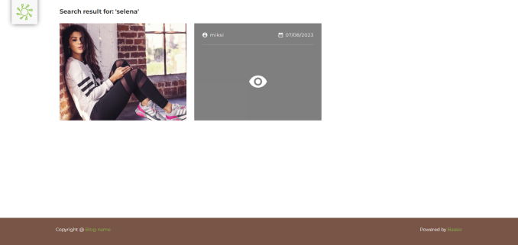 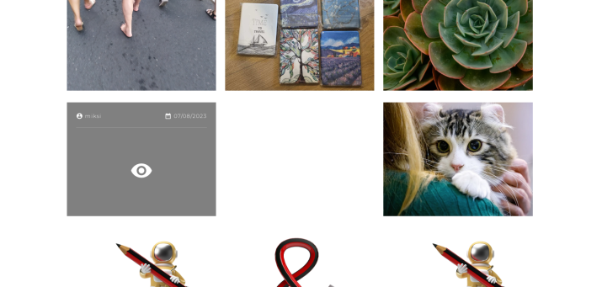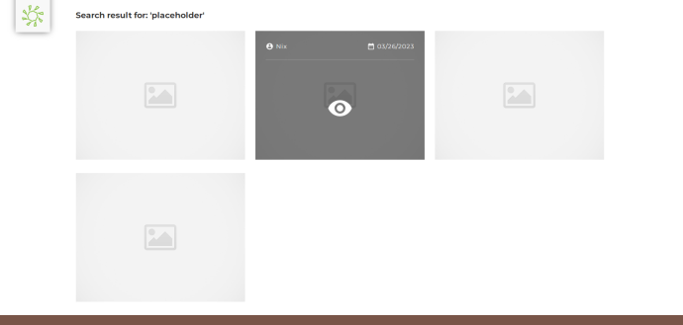 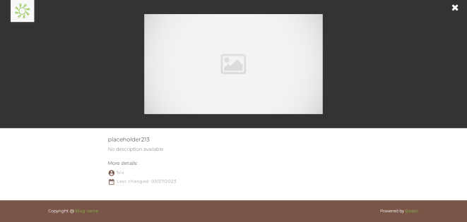

Password recovery link: Identify the issue preventing the functionality of the password recovery link. This issue should be addressed and resolved to enable users to successfully recover their forgotten passwords.

Consistency of search results: It has been observed that the search results are not always consistent and display a different number of photos. It is recommended to adjust and improve the search algorithm to ensure consistency and accuracy of the results.

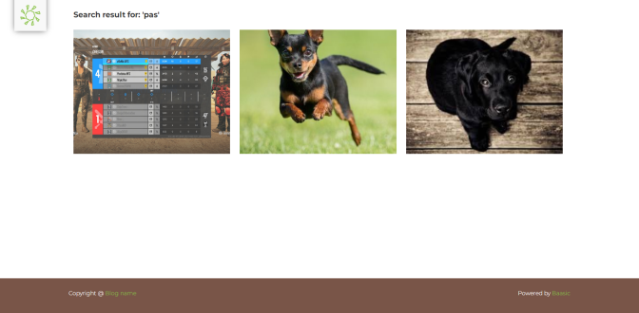 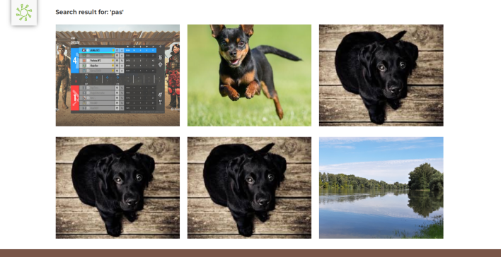

Partial Word Search: We have observed that the partial word search functionality does not meet expectations. The search results display images that do not have a partial word in either the title or description of the photograph. We recommend addressing this issue to ensure more accurate and relevant search results for users.

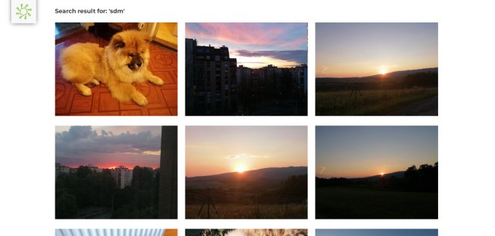 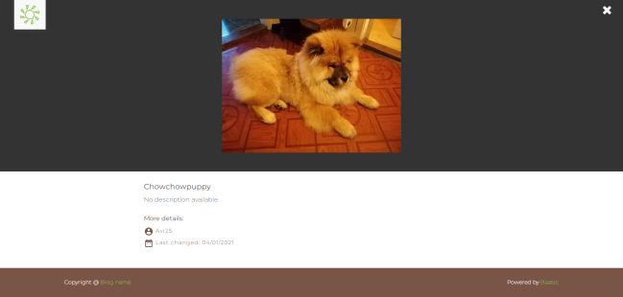

We have observed that the button used to open the gallery is unreliable and often doesn't work on all browsers. Additionally, we have noticed that this functionality does not have issues on older operating systems. It is recommended to thoroughly investigate and address these issues to ensure consistent and reliable gallery opening for all users and browsers.

Overall, there were areas that require further investigation and fixing, specifically related to the photo upload functionality and occasional irregularities observed during photo and album deletion and display. Implementing the recommended improvements will enhance the user experience and ensure the system's functionality aligns with user expectations.

**Test scripts:**

